***Collections and Generics:***

* Collection is a data structure and collection of objects, classes and interfaces
* To overcome the limitation of Array, ArrayList was introduced. Limitation as in fixed size for arrays
* Collection was introduced in Java 1.2, Generics was introduced in Java 1.5 and advanced version is from java 1.7
* Before Collection we had vector but the memory allocation is not handled / utilized properly

***How to declare collection:***

Collection variableName = new ArrayList();

Where collection is an interface and ArrayList is a class.

***How will you use Generics in Collection:***

Collection<Integer> variableName = new ArrayList<Integer>(); // in java 1.5

Collection<Integer> variableName = new ArrayList<>(); // in java 1.7

When you mention the collection, it can take combination of input like integer, string, char, double, float etc., as in

Collection<Integer> name = new ArrayList<>();

name.add(“Ragav”);

name.add(10); likewise you can double, float etc.,

To restrict the collection takes only one kind of data type then use List interface instead of collection interface

To take integer alone

List<Integer> li = new ArrayList<>();

To take string alone

List<String> li = new ArrayList<>();

***Types of List:***

List has two types 🡪 LinkedList and ArrayList.

***List uses / usage:***

* It maintains the insertion order i.e., the output of the list will gives the value in the same order as it is inserted

li.add(“Ragav”);

li.add(“Bala”);

sysout(li); 🡪 Ragav, Bala

* It allows duplicate values i.e., user can add same value multiple times and when you print the list, it displays all the values

***Advantages:***

Array List 🡪 Follows indexing concept, hence searching is easy but deletion in between is time consuming as all the elements move upward or downward based on the deletion position

Linked List 🡪 Stored value with information about the previous and the next node / index value, using which deletion makes easy i.e., the mapping between two elements alone needs shuffling

Some useful functions:

List<String> li = new ArrayList<>();

li.add(“Pakistan”);

li.add(“India”);

li.add(“America”);

**When you want to sort the output of the list in ascending order then use**

Collections.sort(li); where li is the variable name and Collections is the class

**When you want to remove an element then**

li.remove(indexofElement);

**When you want to sort the output in descending order then use**

Collections.sort(li, Collections.reverseOrder());

Or

Collections.sort(li);

Collections.reverse(li);

***Set:***

* Set works the same as List but it won’t allow the duplicate values and won’t maintain the insertion order

Declaration:

Set<String> li = new TreeSet<>();

Types:

1. Treeset 🡪 Note: output will be sorted by default
2. Hashset 🡪 output won’t be in sorted order

Set will not have similar methods as of List as in .get(), .indexOf()

Set can be iterated using iterator

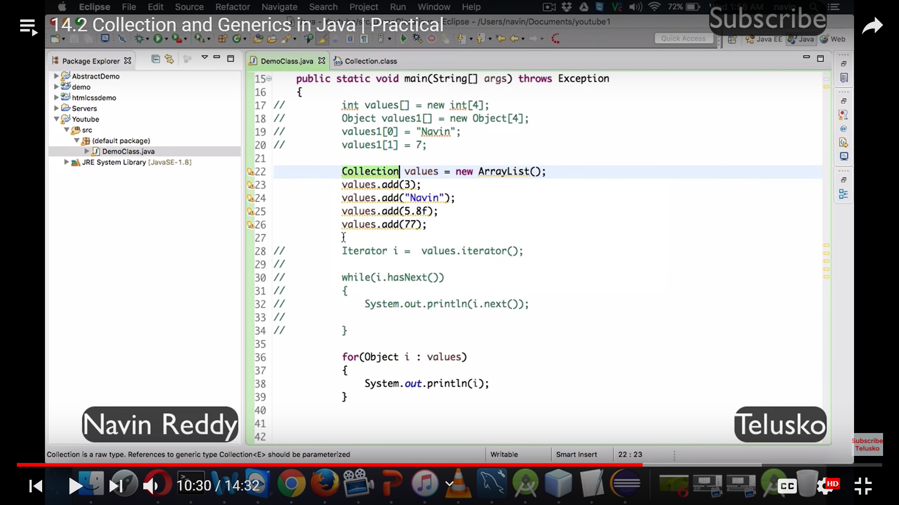

Collections with generics

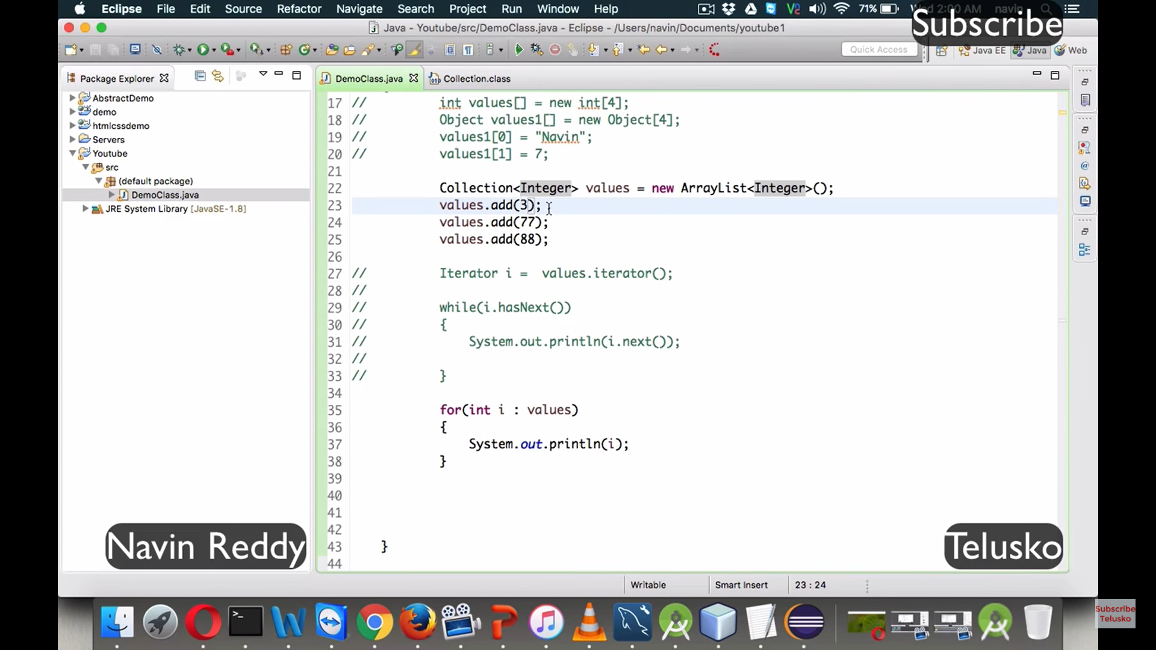

**Generics** is introduced to maintain **type safety** of a variable meaning whether the collections is about integer, string etc

List<**Integer**> country = new ArrayList<>();

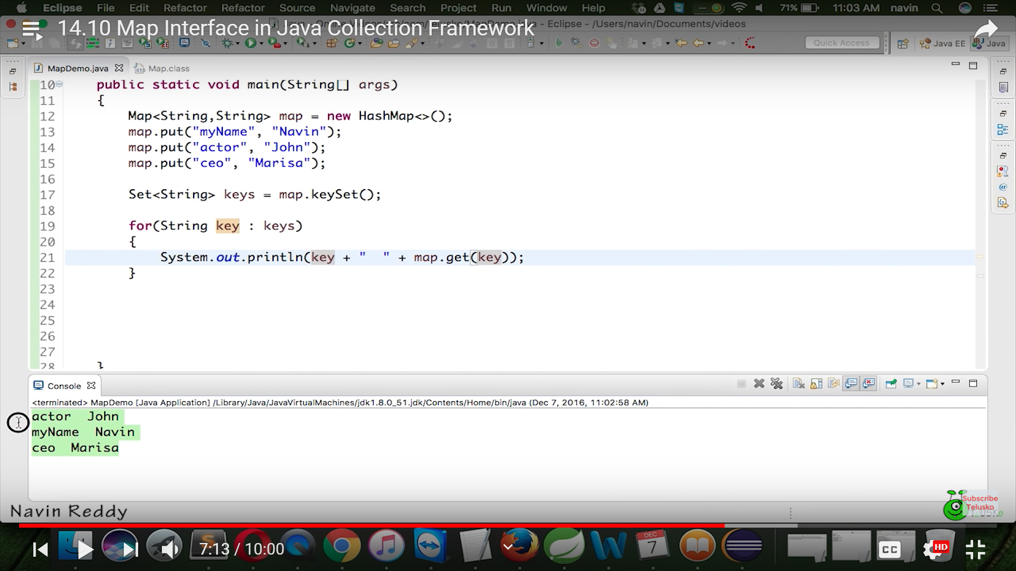

Way to iterate through hashmap

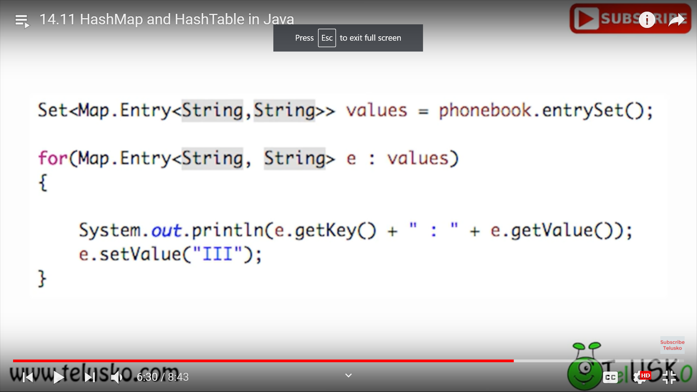

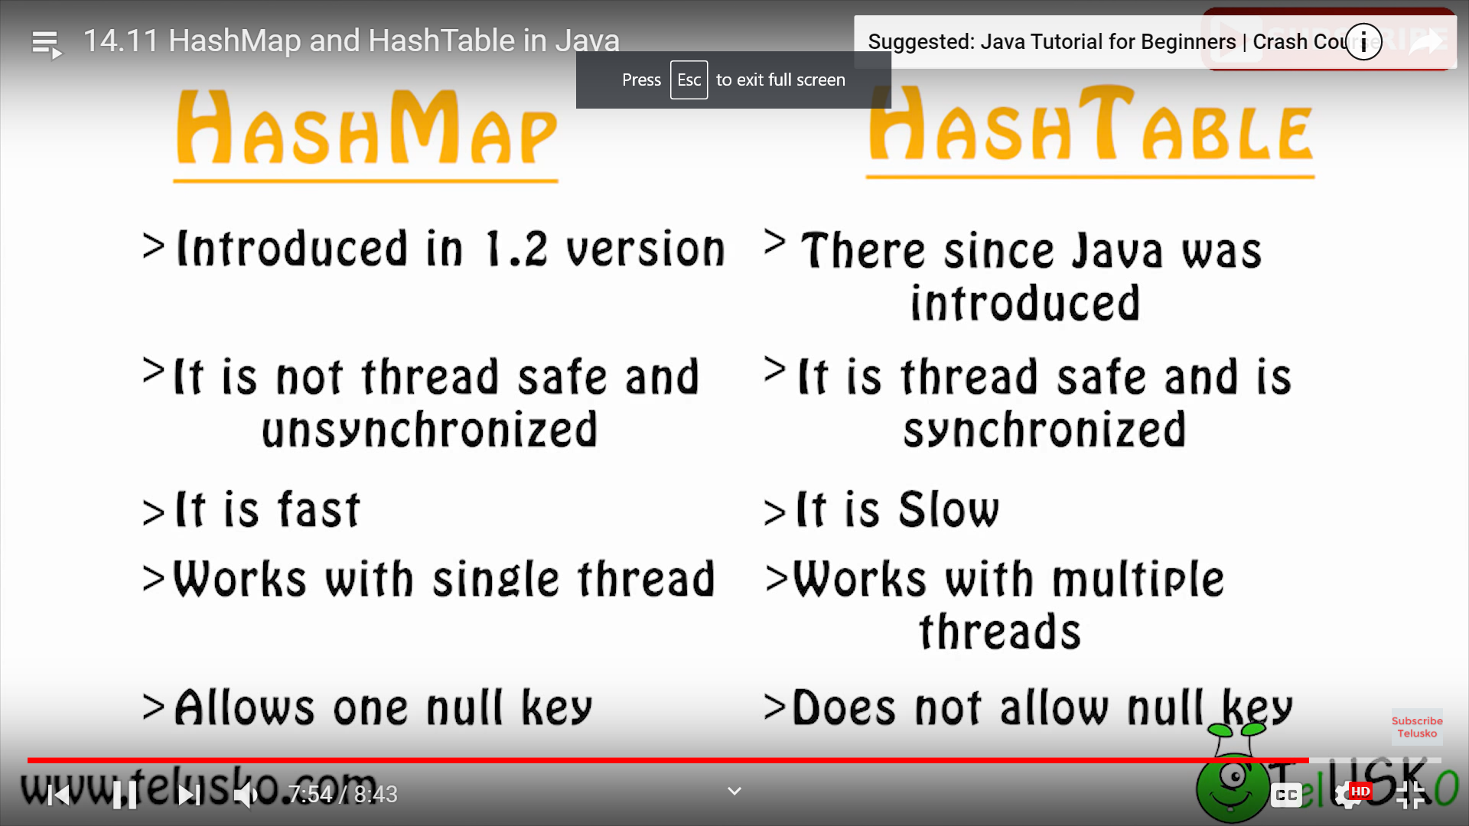

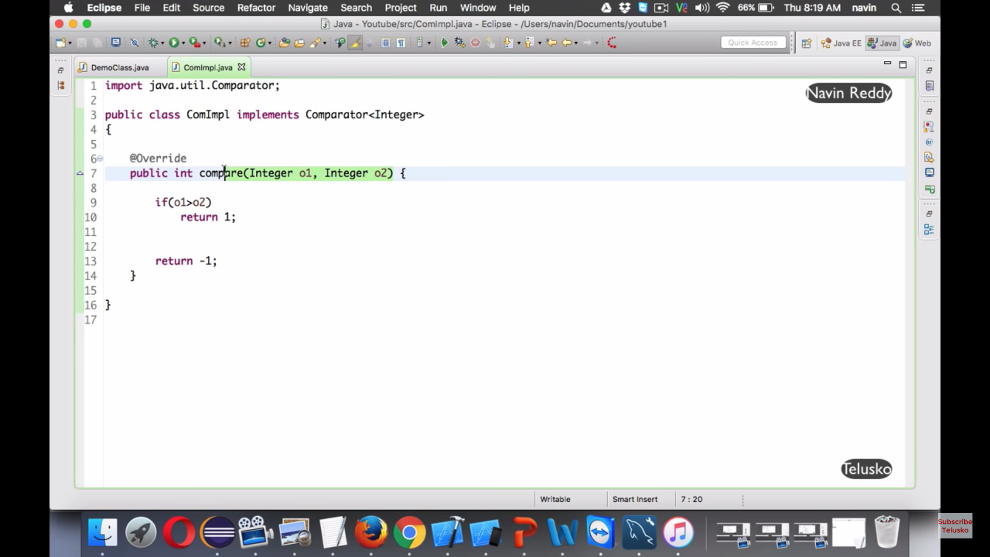

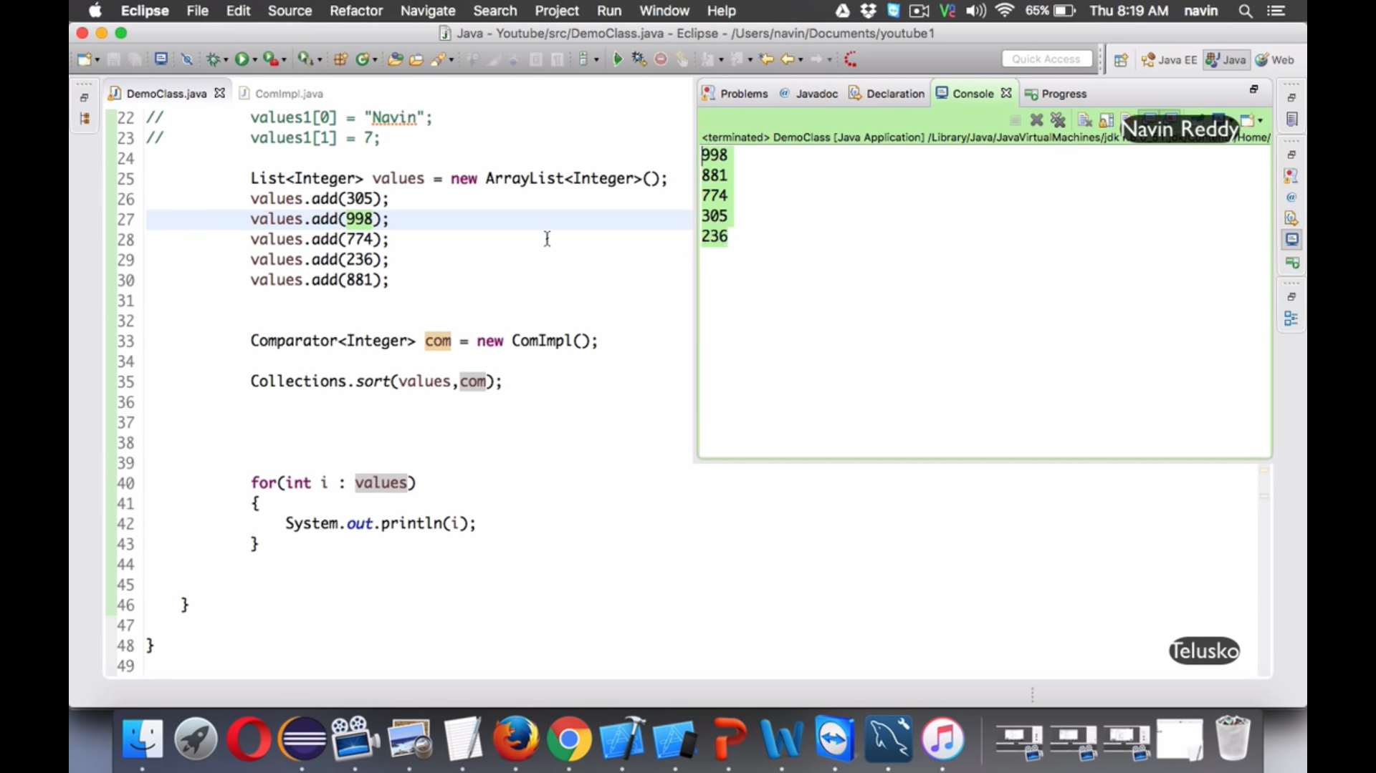

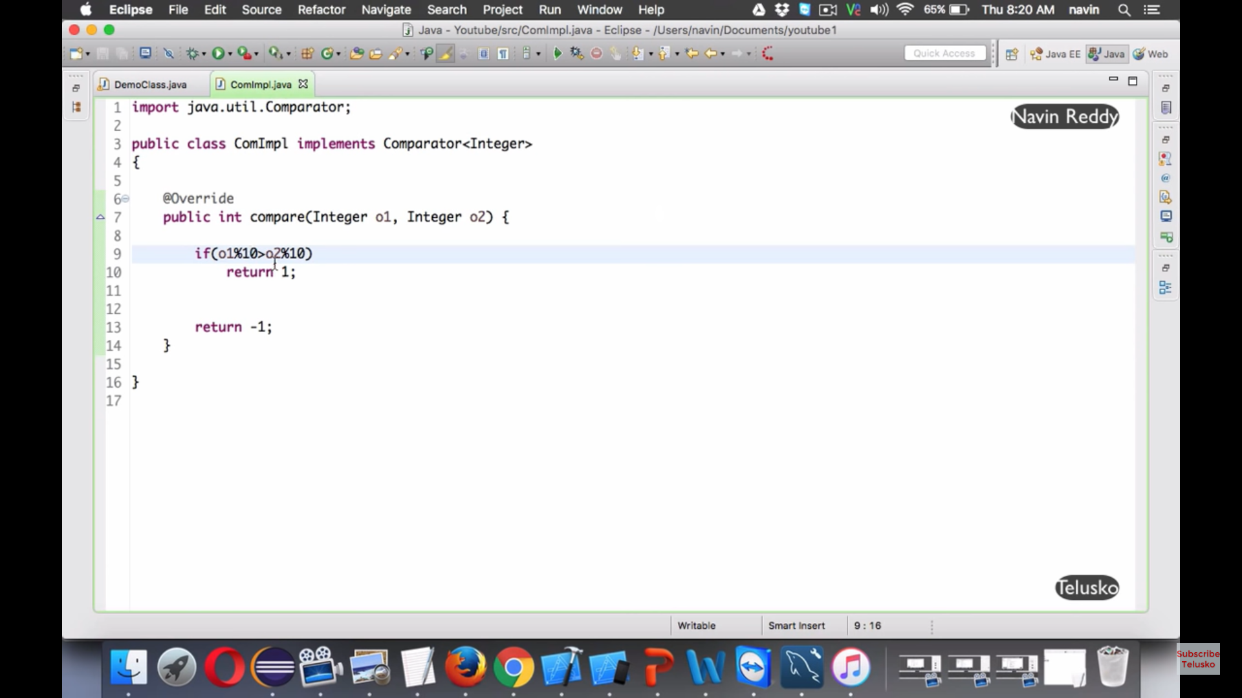

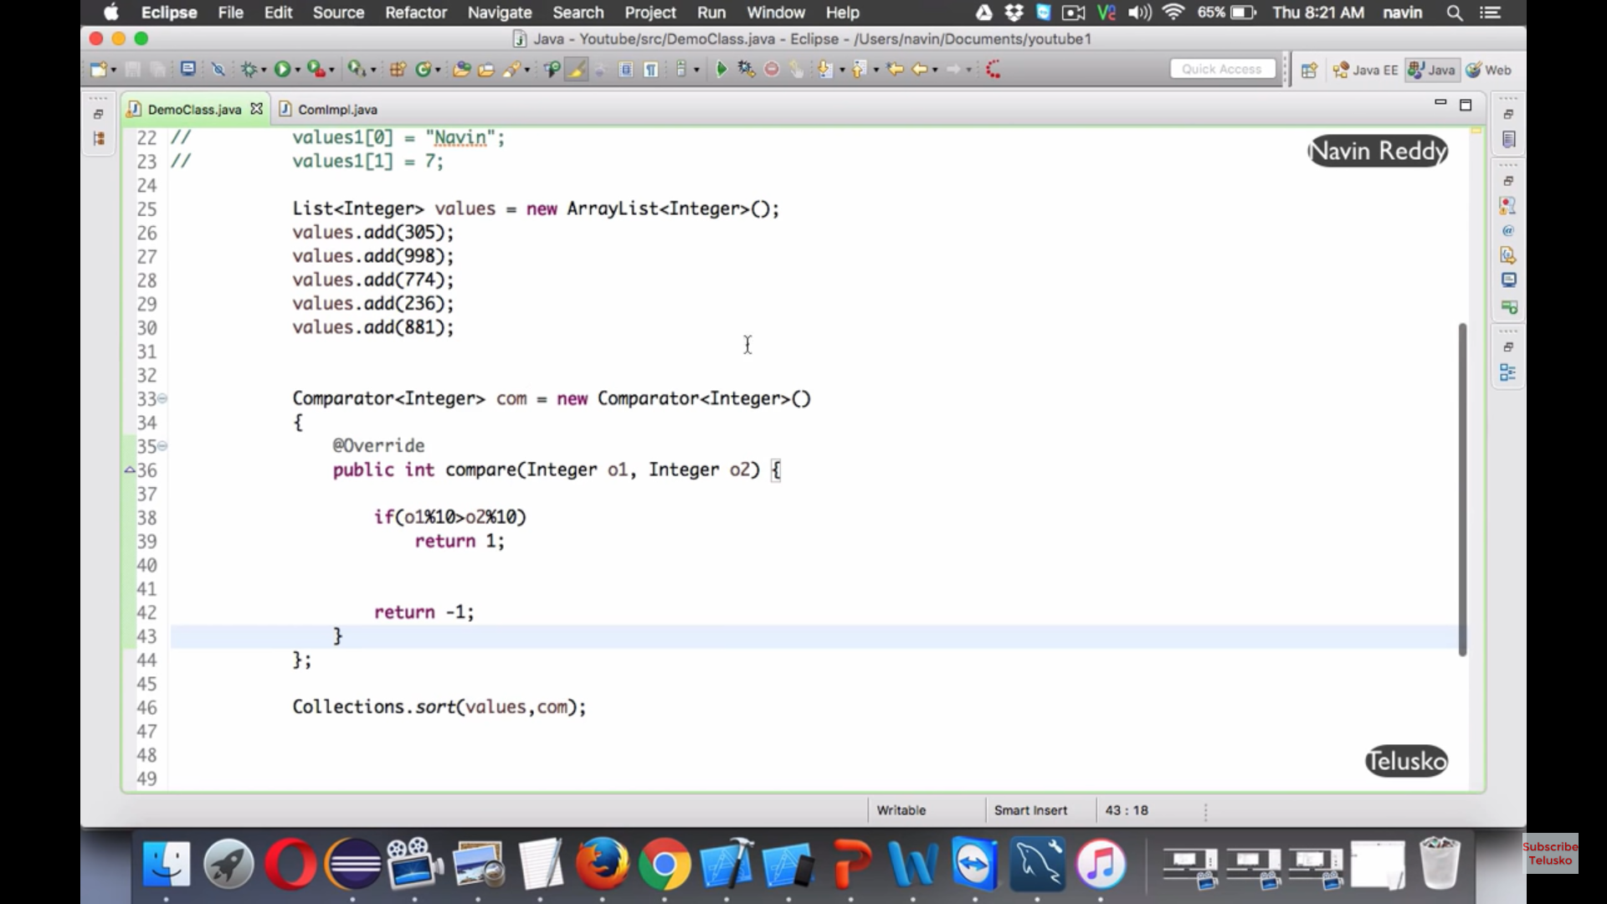

How to print the duplicate elements

